 **Axminster Town Walk**

All rights to the following text and images belong to Axminster Heritage and can only be used by agreement from them.

**Silver Street & Trinity Square**

Start on Silver Street, outside the museum entrance. The next door solicitors’ office building was the Whitty family home, with the original carpet factory (which burned down in 1828) in the yard behind it.

The present museum forms part of the Axminster Heritage Centre, which occupies one half of the replacement carpet factory of 1828 to 1836. Before the fire which prompted its construction there were four cottages here, and before that the Bear Inn. The museum end of the building later housed the town’s first hospital.

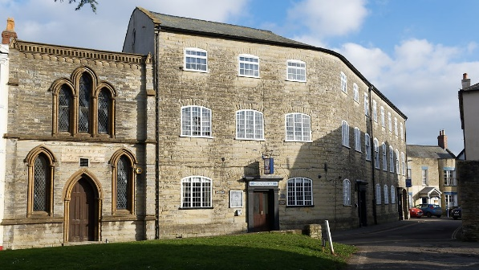

As you walk along Silver Street, towards the Minster Green, you pass the Conservative Club (see photo above), which immediately after carpet making was used for lawyers’ offices and as a court room (1836 to about 1860). The next-door Register Office opened in 1837 to record births, marriages and deaths.

Carry on down Silver Street, and on the other side of Trinity Square you will see Trinity House. This was originally built as a series of smaller shops, after the disastrous town-centre fire of Trinity Sunday 1834 which destroyed 20+ buildings, and allowed a conventional street in front of them to be turned into an open triangle.

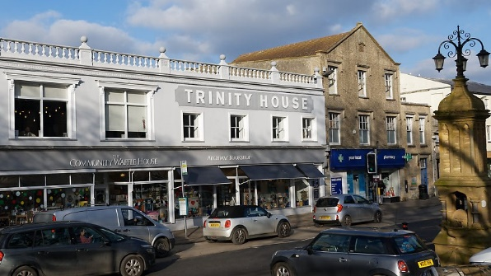

Look at the roof of the taller building in the picture above, and you can see how the front of the pre-fire plot was sliced away at an angle, with a similar effect at the other end of Trinity House. High on the pediment, ‘RCO 1923’ refers to Mr Overmass, who consolidated several shops into one store, and re-built the frontage.

If you stand beside Queen Victoria’s Jubilee Fountain (in the middle of Trinity Square) and look at the other side of the square, you can see the two buildings in the next photograph.

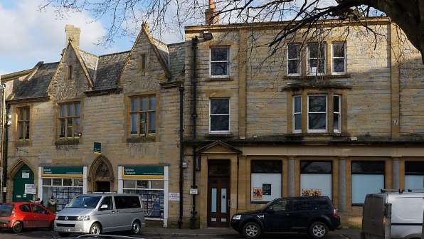

By about 1870 the Dorsetshire Bank occupied what is now the Symonds & Sampson building. Between then and 1914 you would also have seen (in these two buildings) the Wilts & Dorset Bank, then the Devon & Cornwall Bank (where the banking hub is now) and finally Lloyds. In 1902 the Devon & Cornwall Bank refurbished their building, and that was where Lloyds was based after taking over the D&CB. By 1914 Lloyds had bought all three of their rivals, and this is where they stayed until they closed Axminster’s last bank branch in 2022.

On the other side of Symonds & Sampson is the former New Commercial Inn building (see below).

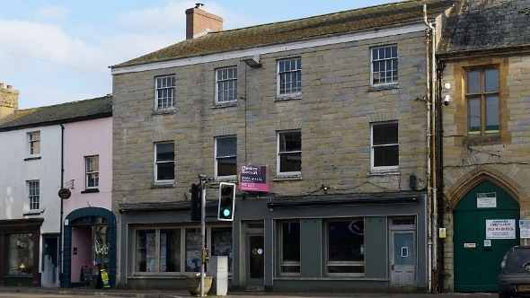

There had been an inn on Cross Street (the predecessor of Trinity Square) for centuries. This side of Trinity Square was damaged by a further (and smaller) fire in 1836, which started in the inn, which was then re-furbished, just before the start of the Victorian era. The New Commercial subsequently housed Gill’s Café and (more recently) River Cottage Canteen. Next door (on the left) is the long-standing sweet shop, before one of several curving frontages typical of the centre of Axminster.

Look a bit further and you’ll see the curved frontage of the Old Bell (as shown in the next photograph). This was one of Axminster’s main inns for at least 200 years, popular with farmers and tradesmen. In 1836, two years after the Trinity Sunday fire, it was largely destroyed (by fire – of course), but was then re-built on the same footprint. Like most buildings in this part of town, the Old Bell had extensive cellars below ground level.



**Victoria Place & Market Square**

If you cross at the pedestrian crossing and turn right, you can follow the curving parade of four shops in what is now Old Bell House. Look for the name carved into sandstone blocks at either end, and at the far end, have a look at the Trafalgar Way plaque, commemorating how the news of Nelson’s naval victory at Trafalgar was spread in 1805.

Across the street from the plaque is The George Hotel, most of which has stood there since about 1760 (when it was built following yet another fire). The extension to the right was added in about 1790, to accommodate dinners, assemblies and auctions. At its peak 16 coaches a day stopped at The George, Axminster being a key stopping point between London and Exeter. In 1958 part of the extension was demolished to widen the street so that it could accommodate ever heavier traffic. Compare what you can see in the next photograph with what is there today.

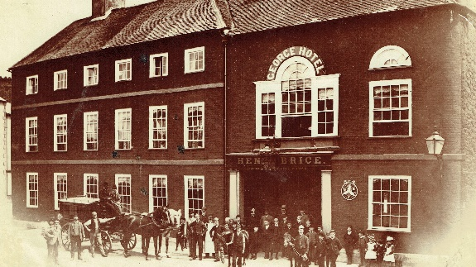

Stay on the same side of the road, and as you walk round the curved frontage, years ago you would have seen Dawkins, which was East Devon’s biggest department store.

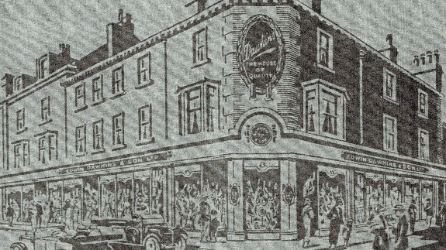

Dawkins used to occupy not just the corner shown here, but several of the buildings beside and opposite, including what is now Costa Coffee. All of the shops on this side of the road date from 1836, having been re-built after the same fire that destroyed the Old Bell. As you continue towards Market Square, look out for the name ‘Mazawattee House’ – showing that there used to be a grocery here selling branded tea.

If you turn left into Market Square, you will see where the old Market House used to stand, before the Regent (silent cinema) buildings took its place.

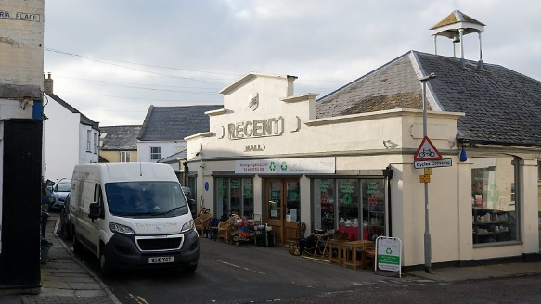

The Blue Plaque on the Regent will tell you more about the history of the market. We know that when it was first established in 1205 it was held on the area known as ‘the castle’ (think Iron Age rather than Windsor Castle!). There is a graphic in the museum showing the probable limits of the earthworks associated with ‘the castle’. For centuries this was where vegetables, corn, cheese and meat (but not live animals) were sold on market days, with some buyers coming from as far afield as the Channel Isles.

**A diversion into Castle Street**

Keeping the Market House on your right, head through the archway in the corner of Market Square, and go down the steps into Castle Street. You will see the old Methodist Chapel (with another Blue Plaque) on your left.

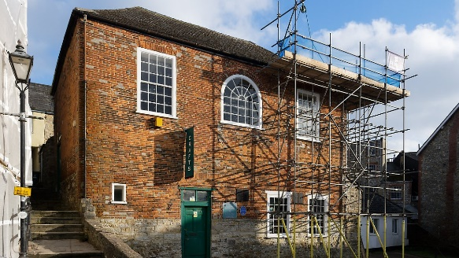

This was Axminster’s first formal Methodist chapel (the Wesley brothers having preached at Axminster several times). Founded in 1796 it was replaced by a new chapel on Lyme Road 98 years later.

Look down the street, and where (as of 2024 and for over a year now) you see some fallen earth and stone behind a fence, that is where the town lock-up (the ‘clink’) was for a few years before the Police Station was built in the 1860s. Its old door and the town stocks are in the museum.

Notice how steeply the ground slopes on both sides of the road: the Iron-age ‘castle’ above took full advantage of the natural lie of the land.

**Back to** **the top of Castle Hill**

Retrace your steps back into Market Square, and turn left as you exit the arch, towards the top of Castle Hill. When you get there, look down-hill towards what used to be James Coate’s brush factory – just this side of the level crossing, and one of three mills driven by the town weir after it was raised in about 1840. The cottages on both sides of Castle Hill housed many of the town’s poorer inhabitants, who had to put up with whatever drained down-hill from their fellow citizens.

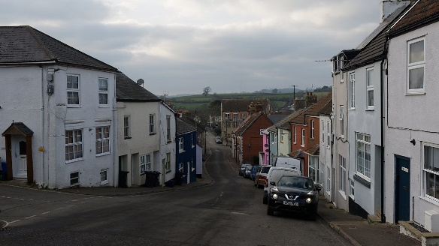

On your left as you look downhill you will see a handsome house, originally called Castle House, now re-named Gloucester House. It was built for Dr Symes and his family in about 1800, after a fire in 1792 had destroyed most of the houses on Market Square. It faces across Castle Hill towards Castle Hill House (between North Street and Old North Street), which from the 1770s was the home of the Hallett family, wine merchants and doctors. The Halletts were also involved in the Axminster Bank, and the town’s last cotton tape-making business. Now turn uphill, towards the Castle Inn.



The Castle is one of Axminster’s newer pubs (its predecessor of the same name was on the other side of Market Square). It and the next-door Castle Mount house occupy a site previously used as the Axminster home of the Yonge family (Tudor MPs and merchants), and then the Dolphin Inn. It was at the Dolphin in 1685 that locally-born John Churchill (later Duke of Marlborough) switched his allegiance from King James II to William of Orange, who was staying there on his way to London. Beneath your feet (and the street) are more cellars, once full of wine and spirits.

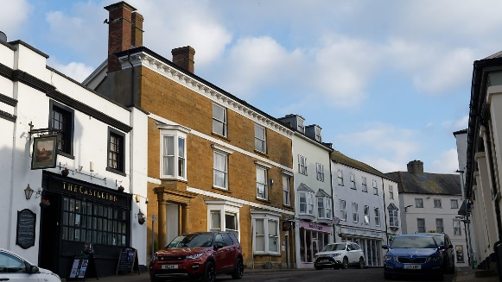

**Round The George to South Street**

Walk back towards to The George, and at the junction turn left along the side of the hotel. When it is safe to do so, cross over so that you can stand close to the entrance to the hotel’s carpark, opposite the two handsome Victorian shops shown on the next photograph.

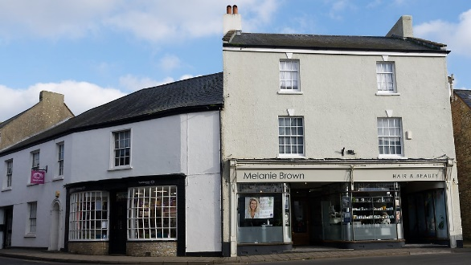

The optician’s shop (on the left) has housed a long list of chemists and similar professionals since the 1850s, while the hairdresser’s (on the right) was for many decades a draper’s shop and men’s outfitter. The name ‘McNeil’ can still be seen as a mosaic in the entrance. Cross over (carefully) onto that pavement, and head for the older white building on the corner (called Pulman House). This was the birthplace of George Pulman, author of The Book of the Axe, and founder of Pulman’s Weekly News.

Cross (carefully!) into South Street, walk past the Postal Sorting Office (with its date, 1938), and look for Buckland House (the only 3-storey building) on the other side of the road.

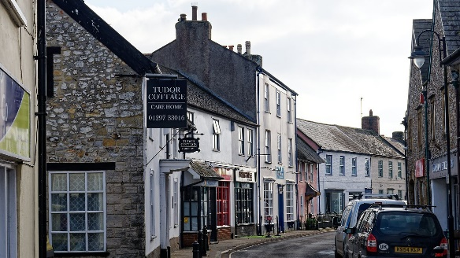

William Buckland was Axminster’s most distinguished son, and first professor of geology and paleontology at Oxford. The museum has lots of information about him and his career. Buckland house was subsequently built by his father, and then after the Bucklands it housed a girls’ school for many years. Next door is Rose Cottage, with an old fire plaque (to show that it was insured) and one of the water pumps from the era before piped and pressurised water.

In the museum you can see several beautifully crafted models of mid-20th century shops, including Mayo’s bakery and Enticott’s greengrocer’s shop. Mayo’s was in the building now occupied by the Co-op, and Enticott’s was directly opposite, where Tindle House is now. As a child, Bill Broom, who made these model, lived in the flat above Mayo’s (see the door marked ‘Upover’), so these were probably the two Axminster buildings he knew best. The museum has several other shop models that he made.

At the far end of South Street you will find Complete Meats – for many years a butcher’s shop, facing directly onto the 20th century livestock market on the opposite side of the street (behind where the Blue Plaque is, on Frank Rowe House). Believe it or not, when this shop was modernised in 1906, a band from Lyme Regis played a concert from the flat roof to celebrate the event!

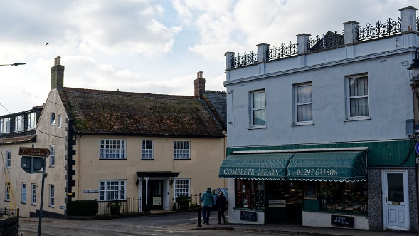

**Church Street & West Street**

As you turn right into Silver Street, you can also admire the house opposite Complete Meats (which is also shown in the previous photograph). This is one of the older surviving houses in the town centre, having been re-built by William Bond, a surveyor, in 1800.

When you reach the Axminster Inn, follow Church Street, past St Thomas’ Medical Centre (see the next photograph).

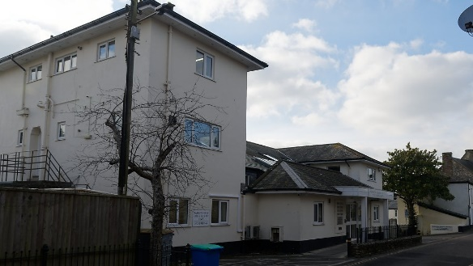

The Axminster Medical Practice based at St Thomas’ Court was established in 1934 by Dr Allen Crockford (who had won the Military Cross in the Great War, served with further distinction in World War II, and was later appointed consultant surgeon to King George VI and then to Queen Elizabeth II). Thanks to him and his vision, and several years before the NHS was conceived of, the people of Axminster enjoyed the benefits of an integrated health centre with doctors, a dentist, an oculist, a physiotherapist and a dispensing pharmacist, all under one roof.

The doorway of Archway Cottage was ‘rescued’ from Newenham Abbey in the mid-19th century by local lawyer Rawlin Mallock (or his father), who owned the building, plus the next-door plot on which Axminster’s original Police Station and a purpose-built court room were built in 1861. This is where you will now find the Arts Café.

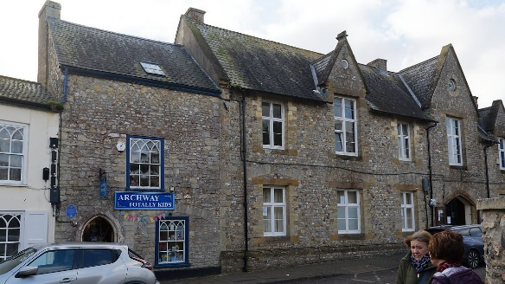

The cross that you can see in the churchyard almost opposite the former police station commemorates the Mallock and Bond families, who were related by marriage. Most of the headstones were removed from the churchyard after it was closed to burials in 1855, but their memorial remained.

In 1800, after yet another big fire, the building next to the former police station (now Belluno) and several more behind it were built. This one became the Hotel Inn, and was later known as the Western Hotel for several decades. Behind it, and facing onto West Street, was where Rev James Small of the Independent chapel on Chard Street ran the ‘Western Academy’ for about 30 years, training young men to become non-conformist preachers. If you go onto West Street to look at it, do take care of the traffic: the corner with Church Street is particularly awkward for pedestrians.



Finish by walking back to Trinity Square. Facing the churchyard used to be the Green Dragon, another of Axminster’s larger inns until it closed in the early 19th century after yet another fire. The next photograph shows the shops that were there in the latter part of the 19th century.

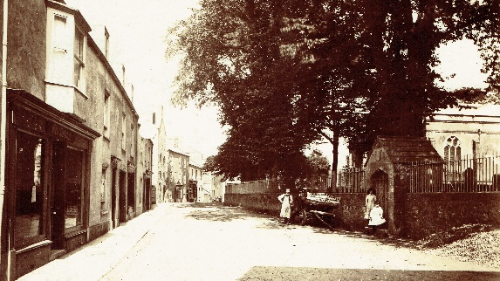

Opposite the west end of the Minster church is where the parish school and workhouse stood until the mid-19th century. Two of the oldest shops are the last one on West Street (which has Axminster Printing behind) and – next to it - the first on Castle Street, which over the years has housed a furniture workshop, wine merchant, cider works and dairy, and is now an estate agency.

|  |  |
| --- | --- |
| As well as beautiful scale models of several of the shops mentioned here, the museum has a series of street-by-street video files showing a mixture of old and new photographs to illustrate how the town has changed over time.  Many of the buildings that you will see on this walk also appear (together with the families who lived or worked in them) in ‘Axminster Legacies, in Wills, Deeds & Stone’, which is sold in support of the museum through its own shop. | C:\Users\David\Documents\Book2\Proofs\Axm Legacies front cover rgb print.jpg |